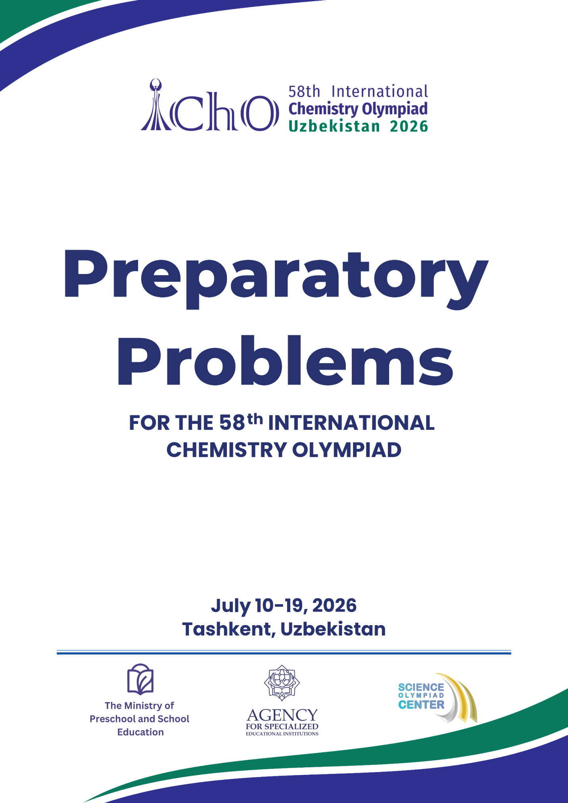

Preface
Dear future participants of the International Chemistry Olympiad, dear friends!
Only six months remain until the annual meeting of the best young chemists from around the world. Today, we are announcing this year's fields of advanced difficulty and publishing a collection of preparatory problems. The Scientific Committee of the 58th International Chemistry Olympiad has brought together the most outstanding Uzbek scientists, recent Olympiad medal winners, and experienced international experts. We are all working hard to present interesting ideas and facts about modern chemistry as the centre of the upcoming competition.
We hope you enjoy the preparatory problems, find them challenging, and spark further interest in chemistry and related sciences. Most of the problems are interdisciplinary, highlighting current trends in human development.
For the first time in history, in 2026, the International Chemistry Olympiad will be held in Central Asia. Uzbekistan is a historical land with deep traditions in science and culture. It is also renowned for its exquisite and diverse cuisine. We have done our utmost to highlight specific features of Uzbekistan in both the theoretical and practical problems, so that you are well prepared to see these in action in July 2026.
We wish you every success in your preparations and selection for your national teams. We look forward to seeing you all in Uzbekistan!
Sincerely,
Members of the 58th IChO Science Committee

Acknowledgements
We would like to express our sincere gratitude to the authors who contributed with interesting and novel ideas for the preparatory and competition problems of the 58th International Chemistry Olympiad (IChO). We greatly appreciate the immense efforts of the international experts who worked hard to bring the tasks up to the highest IChO standards. We thank the organizers of the Abu Rayhan Biruni International Chemistry Olympiad for adapting the format of this competition to that of IChO, giving the Science Committee a unique opportunity to begin real work well in advance. After months of dedicated effort, we have produced a collection of challenging puzzles that cover all major areas of contemporary chemistry. Additionally, we thank the members of the IChO Steering Committee for their invaluable contribution in reviewing and improving the preparatory problems.

List of Contributors
Co-Chairs of Scientific Committee:
Prof. Shamansur Sagdullaev, Yunusov Institute of the Chemistry of Plant Substances, Uzbekistan
Prof. Alexander Gladilin, Moscow State University, Russia
Authors and Reviewers:
Dr. Khamidulla Tukhtaev, King Abdullah University of Science and Technology, Saudi Arabia
Bekhzodbek Boltaev, National Medical Center, Uzbekistan
Prof. Burkhon Elmuradov, Yunusov Institute of the Chemistry of Plant Substances, Uzbekistan
Prof. Khamid Khodjaniyozov, Sadikov Institute of Bioorganic Chemistry, Uzbekistan
Prof. Vadim Eremin, Moscow State University, Russia
Azimjon Jamolov, Nanyang Technological University, Singapore
Dr. Aleksandr Koronatov, Technion – Israel Institute of Technology, Israel & Stratingh Institute for Chemistry, University of Groningen, The Netherlands
Mirumid Mirakbarov, Higher School of Economics, Russia
Dr. Bulat Garifullin, Hospital No. 13 in Ufa, Russia
Dr. Andrei Shved, Lucerne International School, Switzerland
Prof. Yunus Turkmen, Middle East Technical University, Turkey
Prof. Ben Pilgrim, University of Nottingham, UK
Prof. Petra Menova, University of Chemistry and Technology, Czech Republic
Zhihan Nan, Harvard University, USA
Dr. Filip Ilievski, Yale University, USA
Boburbek Boltaev, Cardiovascular Surgery Center “American Hospital”, Uzbekistan
Islomjon Karimov, Center for Advanced Technologies, Uzbekistan
Maftuna Badalova, Nanyang Technological University, Singapore
Ibrohim Temurov, Science Olympiad Center, Uzbekistan
Mirjahon Muhammadov, Science Olympiad Center, Uzbekistan
Elyorbek Adkhamov, Pirogov Russian National Research Medical University, Russia
Azizbek Nazarov, Tashkent State Medical University, Uzbekistan
Sherzod Shaymatov, Tashkent State Medical University, Uzbekistan
Ahrorbek Bahodirov, Moscow Institute of Physics and Technology, Russia
Biloliddin Zukhriddinov, Central Asia University, Uzbekistan
Saida Abdullaeva, Tashkent State Medical University, Uzbekistan
Kirill Kozlov, N. D. Zelinsky Institute of Organic Chemistry, Russia
Dr. Abdurakhim Nabiev, Tashkent Institute of Chemical Technology, Uzbekistan
Dr. Asqar Abdurazakov, Yunusov Institute of the Chemistry of Plant Substances, Uzbekistan
Ikromiddin Boymahammadov, New Uzbekistan University, Uzbekistan
Firdavs Sobirov, Science Olympiad Center, Uzbekistan
Abdulloh Mahmudov, Massachusetts Institute of Technology, USA
Daler Rahimov, Science Olympiad Center, Uzbekistan
Durdona Mukhtorkhodjaeva, D. Mendeleev University of Chemical Technology of Russia in Tashkent, Uzbekistan

Fields of advanced difficulty

Theoretical
- Mass Spectrometry: molecular ions, mass-to-charge ratio, isotope distribution.
- Kinetics: steady-state and quasi-equilibrium approximations, enzymatic kinetics, interpretation of phase portraits.
- Thermodynamics: heat capacity, temperature dependence of equilibrium constant, entropy and enthalpy change.
- Transition metal catalysis: elementary steps in the catalytic cycles with transition metal complexes; single electron transfer (SET) and hydrogen atom transfer (HAT); cross-coupling reactions.
- Photochemistry: Jablonski and Förster diagrams, fluorescence and phosphorescence, quenching, lifetimes, quantum yield.
- Carbohydrate chemistry: represent chair conformations, carbohydrate reactions and protecting groups, repeating units.

The students are not expected to be specifically trained on the hereunder topics:
- Fragmentation in mass spectrometry.
- Advanced calculations (differentiation, iteration).
- Graph theory.
- 2nd and 3rd order kinetics.
- Cycloaddition reaction mechanisms.
- Memorising the structures of canonical amino acids.
- Archaea metabolism.
- Carothers equation.
- Memorising specific values of bond lengths.
- Memorising mechanisms of transition metal-catalysed coupling reactions.
- Details behind the techniques of STM and AFM.

Practical
- Using micropipettes and 96-well plates.
- Vacuum filtration.
- Titration using pH meter.

The students are not expected to be specifically trained on the hereunder topics:
- Recrystallisation.
- Using spectrophotometer.

Physical constants, units, formulae

Constants

Avogadro constant | N_{A} | 6.022 × 10²³ mol⁻¹
Universal gas constant | R | 8.314 J·K⁻¹·mol⁻¹
Faraday constant | F | 96485 C·mol^{–1}
Planck constant | h | 6.626 × 10⁻³⁴ J·s
Speed of light in vacuum | c | 2.998 × 10⁸ m·s⁻¹
Mass of electron | m_{e} | 9.109 × 10⁻³¹ kg
Charge of electron | e | 1.602 × 10⁻¹⁹ C
Standard pressure | P° | 1 bar = 10⁵ Pa
Ionic product of water at 25 ℃ | $$K_{w}$$ | 1.00 × 10⁻¹⁴

Units

Zero of the Celsius scale | 0 ℃ = 273.15 K
Electronvolt | 1 eV = 1.602 × 10⁻¹⁹ J
Watt | 1 W = 1 J·s⁻¹
Coulomb | 1 C = 1 A·s
Nanometre | 1 nm = 1 × 10⁻⁹ m

Formulae

Ideal gas law | $$PV=nRT$$
Dalton law | $$P_{i}=x_{i}P$$
Faraday law | $$n\left(e^{-}\right)=\frac{It}{F}$$
Lambert–Beer law | $$A=\log_{10}{\frac{I_{0}}{I}=εcl}$$
Energy of a photon | $$E=hν=\frac{hc}{λ}$$
Heat and temperature change | $$Q=nC_{m}∆T$$
Gibbs energy definition | $$G=H-TS$$
Gibbs energy and equilibrium constant | $$∆_{r}G°=-RT\ln{K}$$
Enthalpy change dependence on temperature  (at $∆C_{p}$ = const) | $$∆_{r}H_{T_{2}}={∆_{r}H}_{T_{1}}+∆_{r}C_{p}(T_{2}-T_{1})$$
Entropy change dependence on temperature  (at $∆C_{p}$ = const) | $$∆_{r}S_{T_{2}}={∆_{r}S}_{T_{1}}+∆_{r}C_{p}\ln{\frac{T_{2}}{T_{1}}}$$
Henderson–Hasselbalch equation | $$pH=pK_{a}+\log_{10}{\frac{[A^{-}]}{[HA]}}$$
Average reaction rate | $$r=\frac{∆c}{∆t}$$
The rate law | $$r=k{[A]}^{x}{[B]}^{y}$$
Arrhenius law | $$k=A\exp\left(-\frac{E_{a}}{RT}\right)$$
Integrated rate law for a 1st order reaction | $$c=c_{0}e^{-kt}$$  $$kt=\ln{\frac{c_{0}}{c}}$$
Lifetime of a reagent in a 1st order reaction | $$τ=\frac{1}{k}$$
Integrated rate law for n^{th} order reaction (n ≠ 1) | $kt=\frac{1}{n-1}(c^{1-n}-c_{0}^{1-n})$ for n ≠ 1
Concentration of an intermediate in a consecutive reaction: $A\underset{→}{k_{1}}B\underset{→}{k_{2}}D$ | $$\left[B\right]=\frac{k_{1}{[A]}_{0}}{k_{2}-k_{1}}\left(e^{-k_{1}t}-e^{-k_{2}t}\right)$$
The ratio of products in the competitive reactions: $A\underset{→}{k_{1}}B$, $A\underset{→}{k_{2}}C$ | $$\frac{[B]}{[C]}=\frac{k_{1}}{k_{2}}$$
Michaelis–Menten equation | $$r_{0}=r_{max}\frac{{[S]}_{0}}{K_{M}+{[S]}_{0}}$$
Enantiomeric excess ($L$ – $D$) | $$ee=\frac{\left[L\right]-[D]}{\left[L\right]+[D]}$$
Specific surface area | $$s=\frac{S}{m}$$

Math

Progressions:  arithmetic  geometric | $$a_{n}=a_{1}+d\left(n-1\right)$$  $$a_{n}=a_{1}q^{n-1}$$
Sum of geometric progression | $$\sum_{k=0}^{n}{a_{1}q^{k}}=a_{1}\frac{q^{n+1}-1}{q-1}$$
The degree sum for a graph  ($v$ – vertices, E – edges) | $$\sum_{v∈V}{\deg{v}}=2\left|E\right|$$
Volume of cube with edge length $a$ | $$V=a^{3}$$
Surface area of a cube with edge length $a$ | $$S=6a^{2}$$
Volume of a sphere with radius $r$ | $$V=\frac{4}{3}πr^{3}$$
Surface area of sphere with radius $r$ | $$S=4πr^{2}$$
Volume of a cone with base radius $r$ and height $h$ | $$V=\frac{1}{3}πr^{2}h$$
Volume of a rectangular wedge with base $S$ and height $h$ | $$V=\frac{1}{2}Sh$$
Volume of a cylinder with base radius $r$ and height $h$ | $$V=πr^{2}h$$

Consider all gases ideal.

In equilibrium constant calculations, all concentrations are referenced to the concentration of 1 mol dm⁻³.

Periodic table

